

Australian National Contact Point

Complaint Procedures
CONSULTATION DRAFT:
The Treasury has prepared the following draft update to the AusNCP’s specific instance procedures to implement changes resulting from the 2019 restructure of the function.
All significant changes are highlighted in yellow for easy comparison to version 2.0 of these procedures as published at www.ausncp.gov.au. Corrections of minor typographical errors, changes to paragraph numbering, hyperlinks and page numbering are not highlighted.
Version 3.0, xx 2019

Contents
Foreword 2
Application and background 2
1. Introduction 3
2. Submitting a complaint 3
3. Initial assessment 4
4. Good offices 6
5. Final statement 7
6. Post-completion: follow-up 8
7. Post-completion: procedural review 8
8. Timing 10
9. Confidentiality, transparency and conflict of interest 10
10. Withdrawal of cases 11
11. Transitional arrangements 11
12. Glossary 12
Appendix A: AusNCP Complaint Handling Procedure 13

Foreword
This version of the procedures has been introduced to reflect the 2019 restructure of the Australian National Contact Point (AusNCP). The restructure included the introduction of an Independent Examiner to manage all case work and a Governance and Advisory Board which replaced the previous Oversight Committee.
This version replaces version 2.0 originally published in July 2018.
Please direct any queries to the AusNCP Secretariat via email, ancp@treasury.gov.au or by phone, +61 2 6263 3777. Additional information is available at www.AusNCP.gov.au.

Application and background
The Australian National Contact Point (AusNCP) promotes responsible business conduct best practice by building awareness of the OECD Guidelines for Multinational Enterprises (OECD Guidelines) and promoting the role of National Contact Points (NCPs), which help resolve complaints by providing access to mediation and conciliation services.
The AusNCP will receive complaints against enterprises that may not meet the standards of conduct set out in the OECD Guidelines, and will manage those complaints in accordance with the procedures outlined herein.
Australia adheres to the standards set out in the OECD Guidelines as a consequence of its commitment to the OECD Declaration on International Investment and Multinational Enterprises.
The OECD Guidelines for Multinational Enterprises (the OECD Guidelines) are recommendations addressed by governments to multinational enterprises operating in or from adhering countries. They represent a global framework for responsible business conduct covering all areas of business responsibility including disclosure, human rights, employment and industrial relations, environment, anti-corruption, competition and taxation.
A copy of the OECD Guidelines, including implementation procedures and associated commentary, is available in a range of languages at mneguidelines.oecd.org.
Companies operating in Australia and Australian companies operating overseas are expected to act in accordance with the principles set out in the OECD Guidelines and to perform to the standards they suggest. The OECD Guidelines supplement domestic law and are not legally binding.

Introduction
  - This document refers to submissions to the AusNCP as ‘complaints’ or ‘cases’, the individual or entity making the complaint as the ‘notifier’ and the multinational enterprise as the ‘enterprise’. The OECD and NCPs in other countries also use the term ‘specific instance’ to describe a complaint.
  - Complaints will be handled in line with the procedures documented herein.
  - The Independent Examiner (Examiner) will manage all complaints brought to the AusNCP. The Examiner has the authority to publicly share their views through formal AusNCP case publications and make recommendations on cases in line with these procedures.
  - The AusNCP Governance and Advisory Board (Board) and its members are available to the Independent Examiner to provide advice throughout the handling of complaints. Members of the Board may also conduct procedural reviews in accordance with these procedures.
  - A Secretariat will provide support services to the Examiner, including enabling procurement of other professional services as required (such as translation and legal advice). The Secretariat will be staffed by the Australian Department of the Treasury.
  - To support effective implementation of these procedures, the Examiner, Board and Secretariat will have regard to the Procedural Guidance and Commentary in the OECD Guidelines, including the principles of visibility, accessibility, transparency, accountability, impartiality, predictability, equitability and compatibility with the Guidelines.
  - A simplified flowchart of the process is provided at Appendix A.

Submitting a complaint

  - The notifier may be any interested party, however, generally they require a close interest in the issue in order to be able to supply the AusNCP with adequate information. Notifiers acting on behalf of others should be able to demonstrate their authority to do so.
  - A notifier should ordinarily submit a complaint through the form on the AusNCP website: www.AusNCP.gov.au. If a notifier is unable to use the form, the AusNCP will seek to provide reasonable alternate arrangements to ensure the process is accessible (for example email, translation services, or connecting the notifier to a relevant third party for assistance in forming their case). Reasonable arrangements to ensure accessibility will be made for the duration of the case.
  - Complaints can be made to the AusNCP about:
    - a foreign or Australian multinational enterprise operating in Australia; or
    - an Australian multinational enterprise operating overseas, even in a country that is not an adherent to the OECD Guidelines.
  - The Examiner will seek to take a broad view of the definition of an Australian multinational enterprise for the purposes of receiving complaints. Factors such as the entity’s corporate identity and scope of management or control in Australia will be considered.
  - Complaints should clearly demonstrate the link between the issue raised and the enterprise’s actions or responsibilities.

Initial assessment

  - Receipt of a complaint will be acknowledged within five (5) working days.
  - The existence of a complaint will be noted on the AusNCP website within 10 working days of receipt. The only detail to be included will be the name of the country where the complaint is alleged to have taken place.
  - Where a complaint does not contain the information necessary to conduct an initial assessment, the Examiner will work with the notifier to ensure that the required material is provided. Incomplete complaints will be considered invalid if notifiers are unable to provide required information.
  - Complaints concerning a matter that the AusNCP or another NCP is currently handling, or has already handled to completion, may not be considered valid if the substance of the complaint is not markedly different.
  - In line with the circumstances set out in the Procedural Guidance and Commentary in the OECD Guidelines, if the AusNCP is not the correct NCP to handle the complaint, the Examiner may seek to transfer the case to another NCP during the initial assessment stage.
In some circumstances, it may be appropriate for the AusNCP to work with another NCP throughout the handling of a case. In such cases, the lead NCP and cooperating NCP status will be agreed between the relevant NCPs and the procedures of the lead NCP would generally apply.
  - During the initial assessment stage, the enterprise named in the complaint will be notified and provided a copy of the complaint submission.
  - Consistent with the Procedural Guidance and Commentary in the OECD Guidelines, in deciding whether to accept a complaint, the Examiner will consider whether the issue/s raised merit/s further examination by determining whether the issue is legitimate and relevant to the implementation of the OECD Guidelines. In this context, the Examiner will take into account:
    - the identity of the party concerned and its interest in the matter;
    - whether the issue is material and substantiated;
    - whether there seems to be a link between the enterprise’s activities and the issue raised in the specific instance;
    - the relevance of applicable law and procedures, including court rulings;
    - how similar issues have been, or are being, treated in other domestic or international proceedings; and
    - whether the consideration of the specific issue would contribute to the purposes and effectiveness of the OECD Guidelines.
  - To promote accessibility, the Examiner will interpret ‘material and substantiated’ to mean that the issues are plausible and related to the application of the OECD Guidelines, and that there is a plausible link between the enterprise’s activities and the issues raised.
  - The Examiner will inform the Board before conveying the outcome of the initial assessment (to accept, transfer or reject the complaint) to the notifier and the enterprise. The Examiner will not transfer a case before advising the Board, the notifier and the enterprise.
  - The Examiner will then publish information on the case on the AusNCP website, including the names of the parties, the location of the alleged incident, and whether the Examiner has accepted, transferred or rejected the case. If a party raises concerns about being publicly identified in connection with a case, the Examiner will duly consider any representations and determine whether it is appropriate to withhold identifying information.
  - Where the Examiner rejects a complaint, a final statement will be prepared and published in line with the procedures below.
  - Where the Examiner accepts a complaint, the good offices process will commence. The Examiner will invite the enterprise to make a written submission in response to the complaint.
  - Acceptance or rejection of a complaint is not an assessment of whether the enterprise’s actions are consistent with the OECD Guidelines.

Good offices

  - The good offices process will begin with a preparation stage to enable the Examiner to provide information to the parties on the complaint process and prepare a framework for handling any mediation or facilitated discussions. This will be followed by a proceedings phase for discussion of the issues with a view to a resolution.
In practice, it is expected that the good offices process will differ from case to case, and the Examiner will retain a flexible approach to delineation between the preparation and proceedings stages.
  - To begin the preparation stage of good offices, the Examiner will seek to engage each party separately to explain the overall complaint process and options for discussion of the issues. Once received, the Examiner will also share the enterprise’s response to the complaint with the notifier.
  - In consultation with the parties, the Examiner will prepare a plan for discussions in order to give clarity to the process and manage timeframes and expectations. Plans may include each party’s initial objectives, anticipated communication methods and confidentiality arrangements, including whether a formal confidentiality agreement is required. Plans may vary in formality (e.g. an email or a structured document) and will be case-specific, to account for the preferences of each party and any practical constraints that may exist.
  - The Examiner will seek each party’s agreement to proceed with discussions and if:
    - both parties agree, the discussions will commence;
    - the notifier does not agree, the Examiner will prepare a final statement summarising the process followed to date but will not make any further assessment of the issues raised; or
    - the enterprise does not agree, the Examiner will prepare a final statement which will include further assessment of the issues raised.
  - Where the discussions will involve formal mediation, the Examiner may use a suitably qualified third party to conduct the proceedings.
  - At regular intervals, the Examiner will review the progress of proceedings. When the Examiner considers discussions are no longer effective, the issues are resolved or the parties do not require the AusNCP’s involvement to continue, they will conclude the good offices process. The Examiner will consult both parties before making this decision, provide an update to the Board and record the status of the case on the AusNCP website.

  - Following the conclusion of the good offices process, a final statement will be prepared. Both parties may be invited to make a further written submission to support the Examiner’s consideration of the complaint.

Final statement

  - The Examiner will draft a final statement following the rejection of a complaint or the conclusion of good offices.
  - To prepare a statement, the Examiner will review the materials provided by the parties and may also review publicly available information and other information revealed through the good offices process. Advice may also be sought as needed from sources including the Board, another NCP, the OECD Secretariat or other subject matter experts.
  - All final statements will include an overview of the complaint and a description of the process undertaken by the Examiner.
    - Where the complaint was rejected, the final statement will also include an explanation of how the complaint was assessed in the initial assessment process.
    - Where the complaint was accepted but good offices did not result in an agreed outcome, the Examiner will include in the final statement an examination and analysis of the issue and may include a statement as to whether the enterprise’s actions were consistent with the OECD Guidelines.
    - The final statement will include recommendations to the enterprise where appropriate, or other relevant bodies where a systemic issue of direct relevance to the complaint may have contributed.
  - If it is considered useful and is agreed by the parties, the Examiner may initiate or resume the good offices process at any point during the drafting of a final statement.
  - Once the Examiner has prepared their final statement, the Board will be provided with a draft for review and advice. The Examiner is not required to make changes in response to the views of the Board, but may do so at their discretion.
  - A draft final statement will then be provided to both parties for comment. The Examiner may make changes at their discretion.
  - The completed final statement will be provided to parties, the Board, published on the AusNCP website and reported to the OECD. Where recommendations affect bodies other than the parties, the statement will be provided to these bodies. The Examiner has discretion to accommodate any reasonable requests, including from the Board, in relation to sensitivities around publication content or timing.

Post-completion: follow-up

  - The Examiner will specify a timeframe for follow-up on the case in the final statement, provided this is appropriate in the context of the issues involved.
  - In these cases, the Examiner will request an update from both parties on developments since the completion of the final statement.
  - The Examiner may publish a further statement with a summary of the updates received and any commentary on the matter that they consider relevant, including on the extent to which recommendations made in the Final Statement or any mediated outcome have been implemented. They may also recommend an additional follow-up period where they consider this useful.
  - Once the Examiner has drafted their follow-up statement, the Board will be provided with a copy for review and advice. The Examiner is not required to make changes in response to the views of the Board, but may do so at their discretion.
  - The draft follow-up statement will then be provided to both parties for comment. The Examiner may make changes at their discretion.
  - The final follow-up statement will be published on the AusNCP website and shared with the parties and members of the Board.

Post-completion: procedural review

  - Where either party considers that the Examiner has not acted in line with these procedures, they may request a procedural review within 20 working days from receipt of the completed version of the final statement. Late requests for review may be considered where an adequate reason for the delay is provided.
  - Requests can be made by email or post to the Secretariat according to the contact information listed on the AusNCP website. The request must identify the final statement to be reviewed and what procedural irregularity occurred.
  - The Secretariat will acknowledge receipt of a review request within five (5) working days and send a copy of the request to all parties to the case.
  - The Secretariat will notify the Board of a request for procedural review and call for the formation of a Review Committee (the Committee). The Committee will consist of three members from the Board (one government, one non-government, plus one additional member with either a civil society or union background to reflect the multi-stakeholder composition of the Board). Board members may volunteer themselves or their proxies to participate in the Committee. Where there is a surplus of volunteers, the Chair has the discretion to select from the volunteers retaining the composition of; one government, one non-government and one additional member with either a civil society or union background.
  - Board members or proxies who have a conflict of interest should not volunteer for the Committee. Where a majority of the Board considers a volunteer has a relevant conflict of interest, the volunteer may not sit on the Committee. If suitable representation cannot be drawn from the Board or proxies, then members of the Board may nominate one or more external candidates for the Committee. The external candidate/s must be agreed by majority of the Board.
  - The Examiner will provide the Committee with written comments on the review request and any background information they consider relevant to the review. Subject to any confidentiality considerations, this information will be made available to the parties.
  - The Committee will investigate the review request to determine whether there are grounds for concern about the procedural matters raised. The Committee may make enquiries to inform their decision. To facilitate these inquiries, the Committee may share the request for review or seek submissions from any person involved in the original matter (including the parties). The Committee may also consult with other NCPs or the OECD Secretariat.
  - If the Committee determines that material procedural irregularities occurred, they may:
    - remit the decision back to the Examiner with instructions on how to rectify the procedural irregularity; or
    - acknowledge that there were deficiencies in the Examiner’s handling of the complaint and make recommendations as to how those errors can be avoided in the future.
As the review is strictly procedural, the Committee will not examine the substance of any Examiner’s decision and will not replace the Examiner’s decision with their own decision.
  - If the decision is sent to the Examiner for reconsideration, the Examiner will re-open the complaint in accordance with the instructions of the Committee, correct the deficiencies and, if necessary, reconsider their final statement. No further request for review of that action may be made.
  - The Committee will prepare a public statement detailing the request for review, the review process undertaken and its assessment, including any recommendations, for publication on the AusNCP website.
  - The Committee will provide its written assessment to the Examiner and both parties for comment prior to finalising.
  - The AusNCP Secretariat will support the Committee in the conduct of its review and provide the Board with an embargoed copy of the finalised public statement prior to publication on the AusNCP website.

Timing

  - The following table provides timeframes for each phase of the case handling process. Timeframes are indicative of ideal scenarios and cases may take longer.
Phase | Duration
Initial assessment | 8-10 weeks
Good offices – preparation | 10 weeks
Good offices – proceedings | 15-20 weeks
Final statement | 15 weeks
TOTAL | 48-55 weeks
Review | 15 weeks
  - Where delays are anticipated or ongoing, the Examiner will discuss the reason/s with the parties and consider available options to suitably manage the delay. Where delays are significant (greater than 5 weeks), or affect multiple cases, this will be noted on the AusNCP website.

Confidentiality, transparency and conflict of interest

  - It is important for the parties to have confidence that information provided to the AusNCP will be treated sensitively. It will not be released publicly by representatives of the AusNCP without consultation and will only be shared on a confidential basis with those who have a direct role in assisting the Examiner in considering the complaint (for example, members of the Board, service providers such as translators and mediators, other government officials, other NCPs).
  - Information provided by any party to a complaint will only be shared with the other party to the complaint with the consent of the party that provided the information. If a party does not agree to share information, the Examiner will assess whether this is reasonable in the circumstances and where possible, work with the relevant party to excise any sensitive information that may otherwise limit the sharing of the information. Information that cannot be shared between the parties may not be able to form part of the Examiner’s consideration of the case.
  - Information shared between the parties should be kept confidential, including following the conclusion of the complaint, unless the providing party agrees to its disclosure or this would be contrary to the provisions of a national law.
  - Parties should be aware that information and documents provided to the AusNCP will be subject to the operation of the Freedom of Information Act 1982 (FOI Act) and could be released under the provisions of that Act. The FOI Act sets out a process for ensuring the public’s right to access documents held by government, but it does not prevent agencies from disclosing information outside that process.
  - Parties should also be aware that the Australian Parliament can seek the production of information and documents supplied to or created by the Treasury.
  - The Examiner and Board are required to declare any conflict of interest that may arise in relation to a complaint or AusNCP functions more generally. Where a Board member has a conflict of interest, the Board will agree suitable measures to manage the conflict which may include excluding the member from discussions or correspondence about the complaint or issue in question. If the Examiner’s conflict of interest cannot be managed, alternative arrangements will be made by the Secretariat in consultation with the Board to enable the complaint to be handled effectively.

Withdrawal of cases

  - Notifiers may request to withdraw their case in writing to the AusNCP. If this occurs the Examiner will consult the enterprise and close the case. The Examiner will handle public acknowledgment of withdrawn complaints on a case by case basis.

Transitional arrangements

  - These procedures come into effect for all complaints submitted to the AusNCP from the date of publication on this document.
  - Complaints submitted prior to the publication date will be transitioned to these procedures, in consultation with affected parties.

Glossary

The following key terms are defined for the purpose of understanding this procedural guidance.
AusNCP: The Australian National Contact Point.
Complaint/ Case / Specific Instance: A complaint concerning an enterprise’s conduct in relation to the OECD Guidelines. The terms specific instance, complaint and case are synonymous.
Enterprise: The multinational company against which the complaint is made.
Good Offices: Conciliation services offered by the AusNCP intended to help resolve a complaint once it has been accepted by the Independent Examiner.
Governance and Advisory Board: The multi-stakeholder body supporting the AusNCP and Independent Examiner. Further information available at www.AusNCP.gov.au.
Independent Examiner: An independent person, contracted by the Commonwealth of Australia, to manage complaints brought to the AusNCP under the OECD Guidelines and make any recommendations for improvement where appropriate.
Notifier: The individual or entity who submits a complaint to the AusNCP.
OECD: Organisation for Economic Cooperation and Development.
OECD Guidelines: The OECD Guidelines for Multinational Enterprises – an OECD document that articulates international best practice standards for responsible business conduct.
Parties: The notifier and the enterprise.
Secretariat: Administrative and other practical support for the Examiner provided by the Treasury.

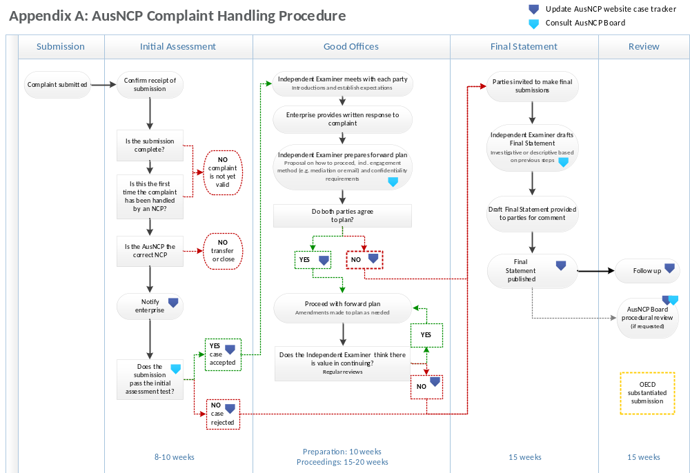
Appendix A: AusNCP Complaint Handling Procedure

The Board Terms of Reference and membership is available at www.AusNCP.gov.au.
OECD Guidelines for Multinational Enterprises 2011.
Further information on page 82, OECD Guidelines for Multinational Enterprises 2011.

